Particular | Details
Department: | Information technology
Programme: | B.Tech-IT
Course Code & Course Name | CSA1711 - AI
Academic Year / Batch | 2024-2028
Faculty Name | DR.K.Krishnakumar
Assignment Title | Deep Learning-Based Deepfake Detection for Social Media Content
Date of Issue | 1/9/2026
Date of Submission | 3/9/2026
Maximum Marks | 100
Course Outcome(s) – CO | CO1,CO2,CO3
Bloom's Taxonomy Level | L6 — Create
SDG Mapping (SDG 1-17) | SDG-7,SDG-9

1. Problem Statement
Social media has made the creation and distribution of visual content almost instantaneous. Images and videos can be recorded, edited, compressed, and reposted within seconds, which makes manual verification increasingly difficult. At the same time, advances in generative artificial intelligence have made it possible to create highly realistic face swaps and other forms of synthetic media. In many cases, visible manipulation artifacts are too subtle for an ordinary viewer to notice
The central problem addressed by this project is the automated identification of facial content that may have been digitally manipulated. A reliable detector should examine the visual characteristics of an image or selected video frames and estimate whether the supplied media belongs to the real or deepfake class. Such a system can support digital-media verification by providing an initial technical assessment before content is trusted, shared, or investigated further.
The proposed solution focuses on a practical student-level deep learning pipeline. It combines frame sampling, face detection, image preprocessing, transfer learning, and binary classification. For videos, representative frames are analysed rather than processing every frame, reducing unnecessary computation while still allowing the system to observe different moments in the sequence. The resulting prediction is intended as an automated screening result rather than an absolute proof of authenticity.

2. Objective
- Develop an end-to-end deep learning workflow that can analyse facial regions in social-media images and videos and distinguish genuine content from manipulated content.
- Extract representative video frames and locate the relevant facial region so that the classifier receives focused visual information instead of the complete, unrelated background.
- Apply transfer learning with EfficientNet-B0 so that a pretrained visual feature extractor can be adapted to the real-versus-deepfake classification task with practical computational requirements.
- Produce a binary classification output in the form of a deepfake probability and a final Real or Deepfake decision based on a defined threshold.
- Assess the system using accuracy, precision, recall, F1-score, and a confusion matrix so that both correct predictions and classification errors can be examined.
- Maintain a modular architecture that can be extended later with temporal modelling, stronger face detectors, explainability methods, cross-dataset evaluation, or additional labelled datasets.

3. Requirements and Environment Used
Software Requirements
Component | Proposed Environment
Language | Python 3.x
Deep Learning | TensorFlow / Keras
Computer Vision | OpenCV
Numerical Processing | NumPy
Data Handling | Pandas
Development Environment | VS Code / Jupyter Notebook
Hardware | CPU; GPU recommended for training
Dataset | FaceForensics++ / Celeb-DF or another appropriately labelled real-vs-fake facial-media dataset
Core Concepts
The implementation is based on convolutional neural network principles, transfer learning, facial preprocessing, binary classification, data augmentation, controlled train/validation/test splitting, frame-level inference, probability aggregation, and standard classification metrics. These concepts work together to convert raw social-media media into a form that can be processed consistently by the deep learning model.

4. Design / Proposed Solution
The proposed system follows a sequential frame-based architecture designed for practical deepfake screening. An image can be processed directly, while a video is first passed through a frame-sampling stage. Sampling at a fixed interval avoids analysing a large number of nearly identical frames and lowers the computational cost of inference. Each selected frame is then examined for a face, and the detected facial region is cropped so that the classifier can concentrate on the area most relevant to face manipulation.
The extracted face is resized to 224 × 224 pixels and prepared in the same numerical format expected by the EfficientNet-B0 network. During training, augmentation can introduce moderate changes in orientation, brightness, and compression so that the model is not dependent on one exact appearance of the training samples. EfficientNet-B0, initialized with ImageNet weights, is used as the main visual feature extractor. Its learned representations are followed by a lightweight classification head
For video input, the individual frame probabilities are combined to form a video-level score. A simple mean aggregation strategy provides an interpretable baseline because every selected frame contributes to the final estimate. A threshold is then applied to convert the score into a binary label. This architecture separates data preparation, feature extraction, prediction, and evaluation, making the prototype easier to test and modify.
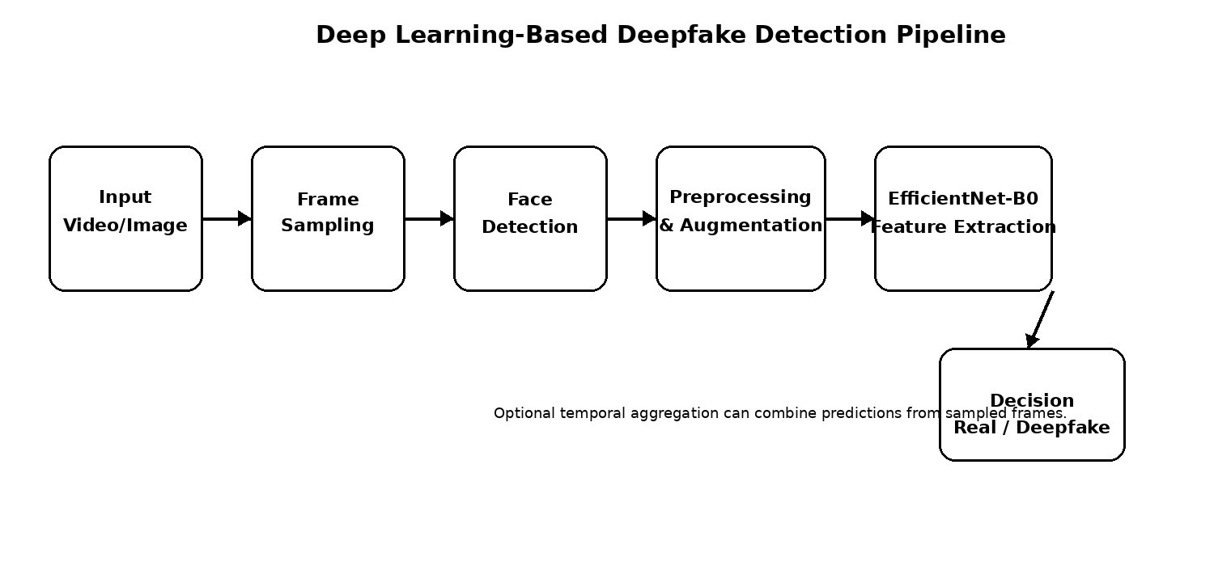
Figure 1: Proposed deepfake detection pipeline

4.1 Data Preparation
Data preparation is an important part of the proposed system because a deepfake detector can easily appear accurate if related samples are unintentionally shared between training and testing. The dataset should therefore be divided at the source-video level whenever possible. Frames originating from the same source video should remain in only one subset so that the model is evaluated on genuinely examples.
Before training, facial images are converted into a consistent input format. Training augmentation may include horizontal flipping, small rotations, controlled brightness variation, and compression changes. These transformations are intended to expose the model to common visual differences encountered in social-media content without changing the underlying class. Validation and test samples should not receive random training augmentation because evaluation should represent a stable and repeatable measurement.
The preprocessing stage also needs to account for difficult inputs such as frames without a detectable face, very small faces, multiple faces, or heavily compressed images. These cases should be handled explicitly rather than silently producing unreliable predictions. Maintaining consistent preprocessing between training and inference is essential because a mismatch can reduce the usefulness of the learned features.
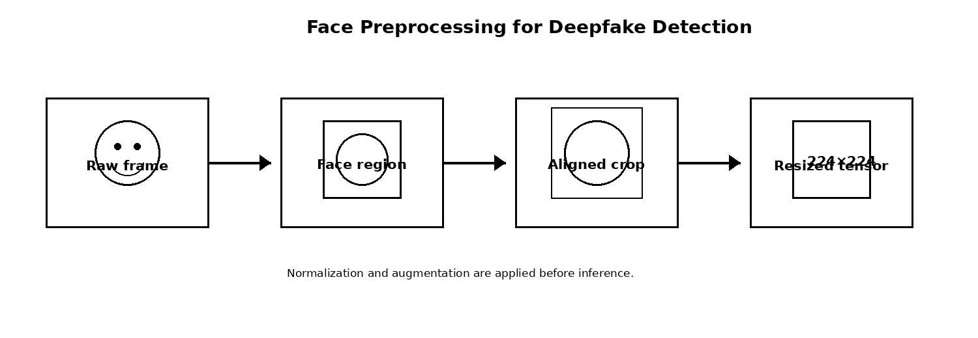
Figure 2: Face preprocessing stages

4.2 Why EfficientNet-B0?
EfficientNet-B0 was selected as the primary backbone because it offers a practical balance between feature quality and computational demand. Instead of increasing network depth, width, or input resolution independently, the EfficientNet family uses a compound scaling approach to maintain a more balanced architecture. For an academic prototype, this provides a useful starting point without requiring the resources normally associated with training a very large network from the beginning.
The use of transfer learning is particularly suitable for this project. The backbone starts with weights learned from a large image dataset, allowing the model to reuse general visual representations such as edges, textures, shapes, and higher-level patterns. The final classification layers can then be adapted to the two target classes: Real and Deepfake. In the compact implementation, the backbone is followed by global average pooling, dropout, a small dense layer, and a sigmoid output unit.
EfficientNet-B0 is not assumed to solve every deepfake detection challenge. Its main strength in this project is that it provides a clear and manageable baseline for spatial facial analysis. More advanced experiments can later fine-tune selected backbone layers, compare alternative architectures, or introduce temporal information from consecutive frames.

5. Algorithm / Pseudocode / Flowchart
Algorithm
Step 1: Accept a supported image or video file from the user or evaluation pipeline.
Step 2: If the input is a video, sample frames at a predefined interval so that representative content is analysed.
Step 3: Detect the face in each selected frame and crop the relevant facial region for classification.
Step 4: Resize every usable face crop to 224 × 224 pixels to match the EfficientNet-B0 input dimensions.
Step 5: Convert the image data to the required numerical format and apply the same normalization used during model development.
Step 6: Feed the processed face image into the EfficientNet-B0 feature extractor.
Step 7: Apply global average pooling and the lightweight dense classification layers.
Step 8: Use the sigmoid output to obtain a value representing the estimated deepfake probability.
Step 9: For video input, combine the probabilities from the sampled frames to obtain one video-level score.
Step 10: Compare the final score with the selected decision threshold and assign the Real or Deepfake class.
Step 11: During evaluation, compare predictions with the known labels and calculate the required performance metrics.
Pseudocode
START
Receive input media
IF input is a video:
Sample representative frames
ELSE:
Use the supplied image as the input frame
FOR each selected frame:
Detect facial region
IF a usable face is found:
Crop the face
Resize to 224 × 224
Normalize the image
Estimate deepfake probability
ELSE:
Record that facial evidence is unavailable
IF multiple predictions are available:
Calculate the video-level probability
IF final probability >= selected threshold:
Return DEEPFAKE
ELSE:
Return REAL
During testing:
Compare predicted and true labels
Calculate evaluation metrics
END

6. Implementation / Source Code
The implementation is organised as a small set of logical components so that each stage can be tested independently. The frame-extraction component handles video sampling, the model component constructs the EfficientNet-B0 classifier, and the prediction component converts frame-level outputs into a final decision. This separation improves readability and makes future changes easier because one module can be replaced without redesigning the entire pipeline.
The screenshots in this section show the compact prototype code used to demonstrate the major processing stages. The implementation is intentionally focused on the core detection workflow rather than on a large application framework. A production-oriented version could add input validation, persistent logging, a web interface, stronger face detection, model versioning, and secure file handling.

6.1 Frame Extraction
The frame-extraction stage reads a video using OpenCV and selects frames according to a fixed sampling interval. This avoids sending every frame to the neural network, which would increase processing time while often adding little new visual information. The selected frames are stored for subsequent face detection and prediction.
The sampling interval is an important practical parameter. A very small interval increases the number of analysed frames and therefore the computational load, while a very large interval may miss useful visual changes. The compact implementation uses a simple fixed-step strategy so that the behaviour is predictable and easy to reproduce. More advanced versions can select frames according to scene changes, motion, or quality.
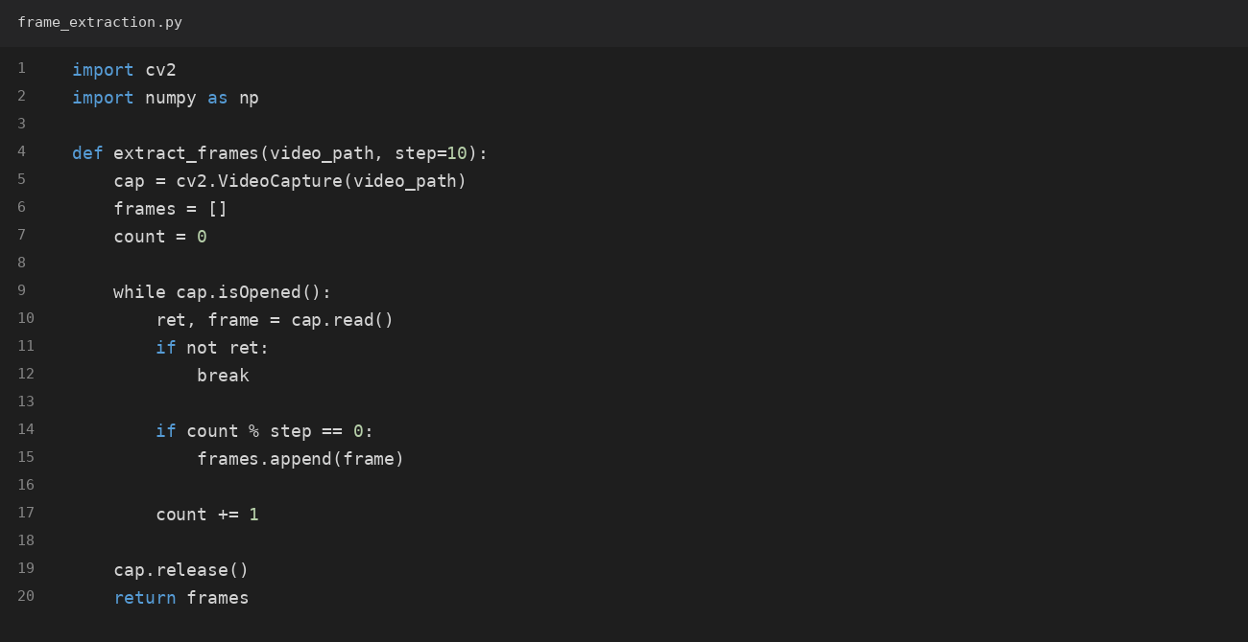

6.2 EfficientNet-B0 Classification Model
The classification model uses EfficientNet-B0 as a pretrained visual backbone. The original classification output is replaced with a project-specific binary head. Global average pooling converts the spatial feature maps into a compact representation, after which dropout can reduce over-dependence on individual features and a dense layer learns task-specific combinations. The final sigmoid unit produces a value between zero and one that is interpreted as the estimated probability of class.
For the initial prototype, the pretrained backbone is kept frozen while the new classification layers are trained. This reduces the number of parameters that need to be updated and provides a stable baseline when the available project dataset or computational resources are limited. Fine-tuning can be considered after the baseline has been evaluated carefully.
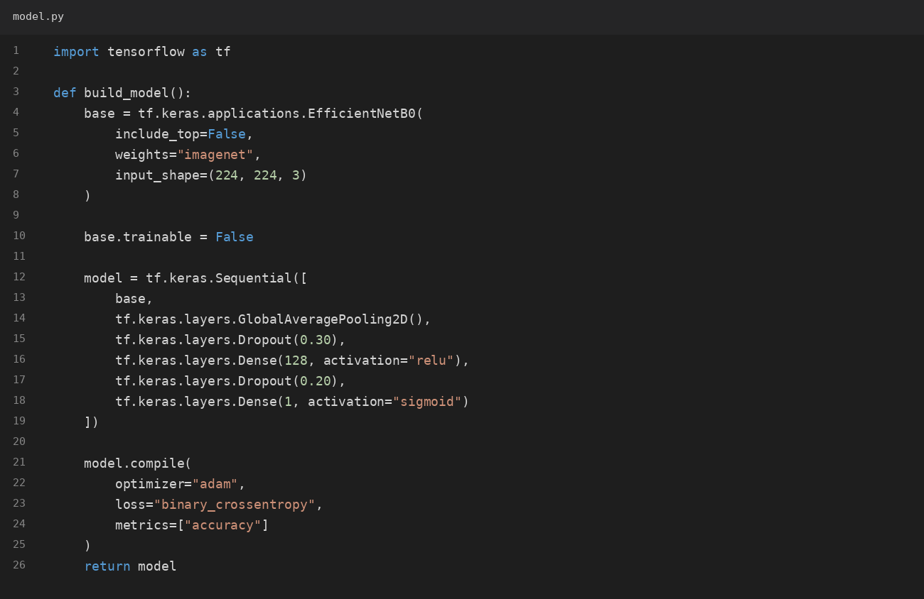

6.3 Video-Level Prediction
For a video, the detector produces a separate score for each usable sampled face frame. These scores are combined using their mean to obtain a single video-level estimate. Averaging is simple, transparent, and suitable for a baseline system because an individual unusual frame does not result.
The final score is compared with the selected threshold. If the score reaches or exceeds the threshold, the video is classified as Deepfake; otherwise, it is classified as Real. The threshold should be treated as an evaluation parameter rather than an unquestionable constant. In a larger experiment, it can be selected using validation data to achieve a desired balance between false positives and false negatives.
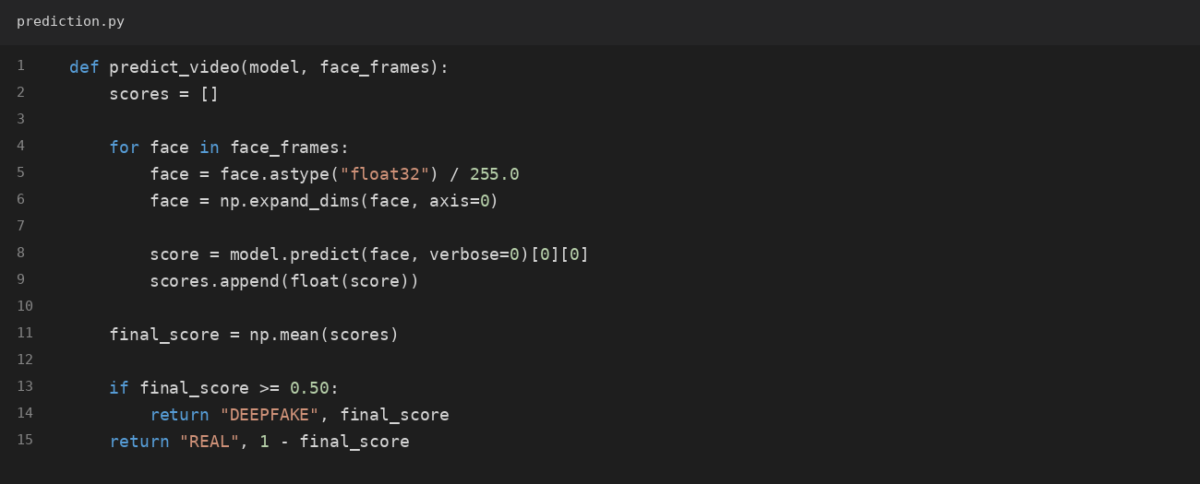

7. Test Cases and Expected / Actual Results
TC | Input / Condition | Expected Result | Actual Result | Status
TC01 | Valid real image | System returns a Real probability and label | To be recorded from the actual execution | Pass when the observed behaviour matches the expected result
TC02 | Valid deepfake image | System returns a Deepfake probability and label | To be recorded from the actual execution | Pass when the observed behaviour matches the expected result
TC03 | Valid video | Representative frames are sampled and their predictions are aggregated | To be recorded from the actual execution | Pass when the observed behaviour matches the expected result
TC04 | No detectable face | System reports that sufficient facial evidence is unavailable | To be recorded from the actual execution | Pass when the observed behaviour matches the expected result
TC05 | Corrupted / unsupported file | System rejects the input safely and reports the input problem | To be recorded from the actual execution | Pass when the observed behaviour matches the expected result
TC06 | Low-resolution face | Prediction completes or the system indicates reduced confidence | To be recorded from the actual execution | Pass when the observed behaviour matches the expected result
TC07 | Multiple faces | System follows the defined face-selection or face-handling rule | To be recorded from the actual execution | Pass when the observed behaviour matches the expected result
TC08 | Batch test set | Evaluation metrics are calculated from the test predictions | To be recorded from the actual execution | Pass when the observed behaviour matches the expected result

8. Execution Screenshots / Output
For the final demonstration, execution evidence should show the input media, the number of frames analysed when applicable, the calculated deepfake probability, the predicted class, and the confidence value. The output shown below is an illustrative report format and should not be presented as measured experimental evidence unless the same values were produced by the actual execution.
Keeping the execution output separate from illustrative values is important for academic reporting. Actual results should be copied directly from the student's model run, while any sample output should be clearly labelled as an example. This distinction prevents unsupported performance claims and makes the report easier to verify.
DEEPFAKE DETECTION SYSTEM
-------------------------
Input: sample_video.mp4
Frames analysed: 20
Average deepfake probability: 0.82
Prediction: DEEPFAKE
Confidence: 82%
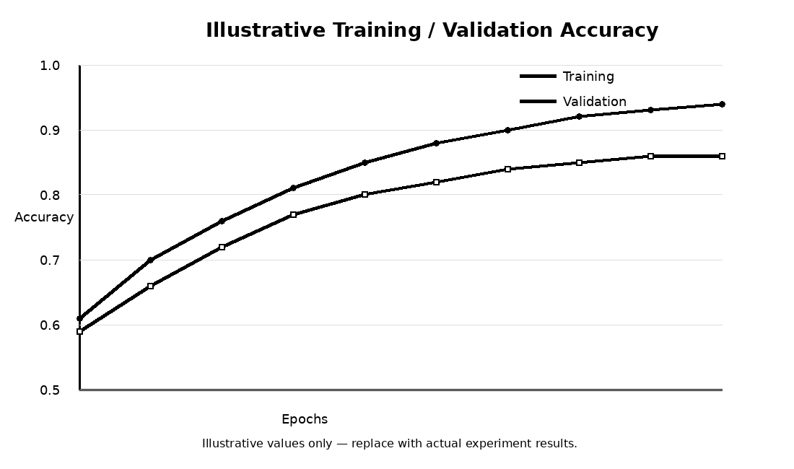
Figure 3: Illustrative training/validation learning curve — replace the displayed values with measurements from the actual model training run before final submission.

9. Analysis and Discussion
Deepfake detection remains a challenging computer-vision problem because manipulation traces are often small, inconsistent, and strongly affected by the quality of the source material. A face that appears clearly manipulated in an uncompressed frame may look considerably different after resizing, recompression, colour changes, or platform-specific processing. Changes in pose, illumination, facial expression, occlusion, and camera quality can also alter the visual patterns presented to the classifier.
The proposed frame-based approach is useful because it concentrates the model on facial evidence and avoids the cost of processing an entire video frame by frame. EfficientNet-B0 provides a compact feature-extraction backbone, while the binary head converts the learned representation into a deepfake score. Because individual frames are evaluated separately, incorrect predictions can also be inspected at frame level, which is helpful for debugging and understanding model behaviour.
However, strong performance on one dataset does not automatically mean that the detector will generalise to unseen manipulation techniques. A model can learn characteristics that are specific to a dataset, compression setting, or generation method. Careful source-level splitting, diverse training data, and cross-dataset testing are therefore important when evaluating the reliability of the system.
Another limitation is that the current prototype primarily relies on spatial information from individual facial frames. Some manipulations are easier to recognise through changes over time, such as unnatural mouth motion, inconsistent blinking, lip-sync errors, unstable facial boundaries, or changes in identity features between consecutive frames. These patterns are not fully represented by a single-frame classifier.
The transfer-learning strategy provides a practical way to build the baseline without training a deep visual backbone entirely from random initialization. EfficientNet-B0 supplies reusable image representations, while the project-specific classification head learns the distinction between the two target classes. Freezing the backbone during the first training stage also reduces computational requirements and makes the experiment easier to reproduce on student-level hardware.
The prediction pipeline is intentionally modular. Frame sampling can be changed without modifying the classification head, and the face-detection component can be upgraded independently. This makes the architecture suitable for future experimentation with different face detectors, data augmentation .
The model should nevertheless be interpreted as a decision-support system rather than an infallible authenticity verifier. A probability score expresses the model's learned confidence under the conditions represented in its training data; it does not establish the origin or intent of the media. This distinction is especially important when the detector is applied to real-world social-media content that differs from the training distribution.
A major limitation of the compact prototype is the absence of an explicit temporal learning mechanism. Deepfake videos may contain inconsistencies that become visible only when several consecutive frames are considered together. Future work can therefore introduce an LSTM or GRU over frame features, a temporal transformer, or a three-dimensional convolutional network. These approaches can learn relationships between frames instead of treating each frame independently.
Explainability can also strengthen the system. Techniques such as Grad-CAM can be used to visualise regions that contribute strongly to a prediction, helping researchers determine whether the model is focusing on meaningful facial areas or on unintended background and compression cues. Additional improvements may include stronger face alignment, quality-aware frame selection, cross-dataset evaluation, calibration of probability scores, and a web or mobile interface for controlled user testing.

9.1 Evaluation Metrics
Accuracy gives the proportion of all samples classified correctly, but it should not be used as the only measure of a deepfake detector. Precision indicates how reliable the positive Deepfake predictions are, while recall indicates how effectively the system identifies the available deepfake samples. F1-score provides a single measure that balances precision and recall. A confusion matrix gives a direct view of negatives.
These measures are particularly useful when the two classes are not perfectly balanced. For example, a detector may achieve a high accuracy value by favouring the larger class while still missing a substantial number of manipulated samples. ROC-AUC can provide an additional view of how well the model separates the classes across different decision thresholds. Therefore, the final evaluation should report the metrics supported by the actual test run rather than relying on illustrative values.
Accuracy = (TP + TN) / (TP + TN + FP + FN)
Precision = TP / (TP + FP)
Recall = TP / (TP + FN)
F1-score = 2 × Precision × Recall / (Precision + Recall)

10. Conclusion
The Deep Learning-Based Deepfake Detection system presents a structured approach for screening manipulated facial content in social-media images and videos. The workflow combines video frame sampling, facial-region extraction, image preprocessing, EfficientNet-B0 transfer learning, and binary classification.
The project also demonstrates that the quality of the evaluation process is as important as the model architecture. Source-level dataset separation helps reduce data leakage, while consistent preprocessing ensures that training and inference operate under comparable conditions. Reporting accuracy together with precision, recall, F1-score, and a confusion matrix provides a more informative view of system behaviour. Actual experimental values should be taken from the final model execution rather than from illustrative
Overall, the proposed architecture provides a practical foundation for further development in digital-media verification. Its current spatial approach can be strengthened by temporal modelling, improved face alignment, cross-dataset validation, explainable AI, and deployment through a controlled web or mobile interface. The system should be used as an assisting verification mechanism, with final judgements supported by appropriate human or forensic review when the application is high-stakes.
The work also shows why generalisation must be treated as a core design requirement rather than an optional improvement. Deepfake generation methods continue to change, and social-media platforms can alter the visual characteristics of uploaded content through compression and resizing. Consequently, a model that performs well under controlled test conditions may behave differently on unfamiliar media.
With these improvements, the project can evolve from a compact academic prototype into a more comprehensive research system. The modular design makes such extensions feasible because the preprocessing, model, prediction, and evaluation stages are already separated. The current implementation therefore serves as a clear baseline from which more advanced and robust deepfake detection experiments can be developed.

11. Individual Contribution of Group Members
Roobini.S(192421114) – Dataset and Preprocessing: Organised the real and manipulated samples, established the dataset split, prepared frame sampling, handled facial-region extraction, and defined the training augmentation strategy. Detection and Testing: Implemented inference, frame-level probability generation, video-level aggregation, threshold-based classification, test cases, and evaluation procedures.
BELLAMKONDA BHARGAVI(192311136) – Deep Learning Model: Developed the EfficientNet-B0 transfer-learning architecture, configured the binary classification head, selected the training setup, and reviewed the model-learning behaviour. Documentation and Analysis: Prepared the system architecture, workflow diagrams, output presentation, performance discussion, limitations, conclusion, and final technical documentation.

12. References
- Rössler, A., Cozzolino, D., Verdoliva, L., Riess, C., Thies, J., and Nießner, M. (2019). FaceForensics++: Learning to Detect Manipulated Facial Images. Proceedings of the IEEE/CVF International Conference on Computer Vision.
- Li, Y., Yang, X., Sun, P., Qi, H., and Lyu, S. (2020). Celeb-DF: A Large-Scale Challenging Dataset for DeepFake Forensics. Proceedings of the IEEE/CVF Conference on Computer Vision and Pattern Recognition.
- Afchar, D., Nozick, V., Yamagishi, J., and Echizen, I. (2018). MesoNet: a Compact Facial Video Forgery Detection Network. IEEE Workshop on Information Forensics and Security.
- Tan, M., and Le, Q. V. (2019). EfficientNet: Rethinking Model Scaling for Convolutional Neural Networks. Proceedings of the 36th International Conference on Machine Learning.
- Yan, Z., Zhang, Y., Yuan, X., Lyu, S., and Wu, B. (2023). DeepfakeBench: A Comprehensive Benchmark of Deepfake Detection. Advances in Neural Information Processing Systems.
- Goodfellow, I., Bengio, Y., and Courville, A. (2016). Deep Learning. MIT Press.
- LeCun, Y., Bengio, Y., and Hinton, G. (2015). Deep Learning. Nature, 521, 436–444.
- He, K., Zhang, X., Ren, S., and Sun, J. (2016). Deep Residual Learning for Image Recognition. Proceedings of the IEEE Conference on Computer Vision and Pattern Recognition.
- Selvaraju, R. R., Cogswell, M., Das, A., Vedantam, R., Parikh, D., and Batra, D. (2017). Grad-CAM: Visual Explanations from Deep Networks via Gradient-Based Localization. Proceedings of the IEEE International Conference on Computer Vision.
- Kingma, D. P., and Ba, J. (2015). Adam: A Method for Stochastic Optimization. International Conference on Learning Representations.
- Goodfellow, I. J., Pouget-Abadie, J., Mirza, M., et al. (2014). Generative Adversarial Nets. Advances in Neural Information Processing Systems.
- TensorFlow / Keras Documentation. Deep learning APIs for model construction, training, preprocessing, and inference.

13. One-Page Write-up
The rapid growth of social-media platforms has made visual communication fast and accessible, but it has also increased the difficulty of verifying whether online images and videos are authentic. Modern deepfake techniques can alter facial identity and appearance with a level of realism that may be difficult for viewers to recognise. Compression, resizing, lighting differences, and low-quality uploads can make manual inspection even less dependable. The proposed project, Deep Learning-Based Deepfake Detection for Social Media Content, addresses this challenge through an automated deep .
The system begins by accepting an image or video as input. When the input is a video, representative frames are sampled at a fixed interval rather than processing every frame. This reduces redundant computation while retaining information from different points in the sequence. A face detector is then used to identify the relevant facial region. The detected face is cropped, resized to 224 × 224 pixels, and normalised so that it matches the expected model input format.
The prepared facial image is passed to an EfficientNet-B0 network used as a transfer-learning feature extractor. Instead of training a large visual model entirely from scratch, the project reuses general visual representations learned from a pretrained model and adapts the final classification layers to the two project classes. The classification head produces a sigmoid-based probability representing the estimation.
For video input, predictions from the selected frames are combined to obtain a video-level probability. A decision threshold is then used to convert that score into the final Real or Deepfake label. This frame-based strategy is straightforward to implement, easy to inspect, and suitable as a baseline for a student-level deepfake detection system. The evaluation stage should measure accuracy, precision, recall, F1-score, and confusion-matrix values so that both correct classifications and different types of errors are visible.
An important design principle is careful evaluation. Deepfake datasets can contain multiple manipulation methods, different video qualities, and varying compression levels. Frames from the same source video should not be distributed across training and testing subsets because doing so can create data leakage and make the measured performance appear better than the true generalisation ability. Training augmentation can introduce moderate variations in brightness, orientation, and compression so that the classifier is less dependent on a single visual presentation.
The project also recognises that deepfake detection is not solved by a single spatial classifier. Some manipulations reveal temporal inconsistencies involving facial motion, lip synchronisation, blinking, or identity continuity. Future versions can therefore add LSTM, GRU, transformer-based temporal processing, or 3D convolutional networks. Cross-dataset testing and explainability methods such as Grad-CAM can further strengthen evaluation and interpretation.
The current architecture is intentionally modular, allowing individual components to be improved without redesigning the complete workflow. A stronger face detector or alignment method can replace the existing facial preprocessing stage, while the EfficientNet backbone can be fine-tuned or compared with alternative architectures. The system can also be packaged into a web or mobile application for controlled demonstrations in which users upload media and receive a prediction together
In conclusion, the project provides a practical framework for deepfake screening by combining facial preprocessing, EfficientNet-based feature extraction, binary classification, and systematic evaluation. The system should be viewed as an assisting verification tool rather than a guaranteed authenticity judgement. Its modular structure creates a useful foundation for future research into more robust spatial-temporal deepfake detection and responsible digital-media verification.
The current architecture can be extended in several ways. Temporal models such as LSTM, GRU, transformers, or 3D convolutional networks can capture inconsistencies that occur across consecutive frames. Explainable AI methods such as Grad-CAM can highlight facial regions that influenced a prediction. Cross-dataset testing can measure whether the model remains reliable when it encounters previously unseen manipulation techniques. A web interface can also be developed so that users can upload media and receive a detection result.
In conclusion, the proposed project provides a structured and practical framework for deepfake detection using deep learning. By combining facial preprocessing, EfficientNet-based feature extraction, binary classification, and systematic evaluation, the system can assist in identifying suspicious social media content. Although no detector should be treated as infallible, the architecture provides a strong foundation for further research and responsible digital-media verification.

